The rxFinder
Jo-Ann Montejo Taneo

i. Problem Statement

Rationale
Have you ever been in a rush of finding the nearest available pharmacy that sells the prescribed medicine during emergency situations? Or the hassle of moving from one store to another, only to find out that the medicine is out of stock or is never available?
The current system of people lining up with priority numbers, wasting time waiting for their turn is becoming inefficient especially if the product is not available. If only a service to provide real time data of product availability exists, then it becomes a competitive strategy for a company eliminating longer queues just for product inquiry.
Proposed Solution
The proposed solution is to build a web application for a certain group of company, serving as an interface accessing all its branches to provide their customers the service to check store and product availability. The website should be responsive for it to be available in mobile for easier access.

Scope and Limitations
This project assumes that an existing inventory system already exists for the company and its branches. For development sake, the data to be used during testing will be imported to a dummy database for the web service to query. Each branch will have a dummy database.

Product Perspective

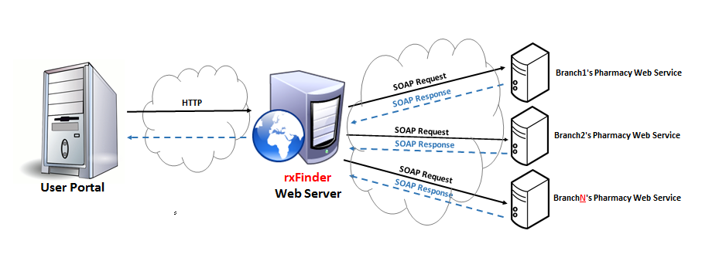

Product Functions
- Web Service for each branches
- A separate system provided to all its branches. It will run a web service for the portal to call once the customer queries for location and product availability.
- This web service accesses the branch database as source of data.
- Customer Portal
  - Log-in
The website will provide log-in to users before they can use the functionalities of the system. Two account types are expected to operate the system:
- Administrator – Full control of the system.
- Customer – Query for the branch and product availability.
  - Update profile
- Ability to change the current location. The location will allow the system to locate the user’s nearest branch.
  - Maintenance
The website enables an administrator to manage the system, having the ability to maintain the list of branches and to users.
  - Branch Finder
Customers can provide their current location for the system to check the nearest available branch it can find.
  - Product Finder
Customers can provide the generic name and/or specific product name for the system to check which branch nearest to his location or specific location has the product available.

ii. Use Case Diagram

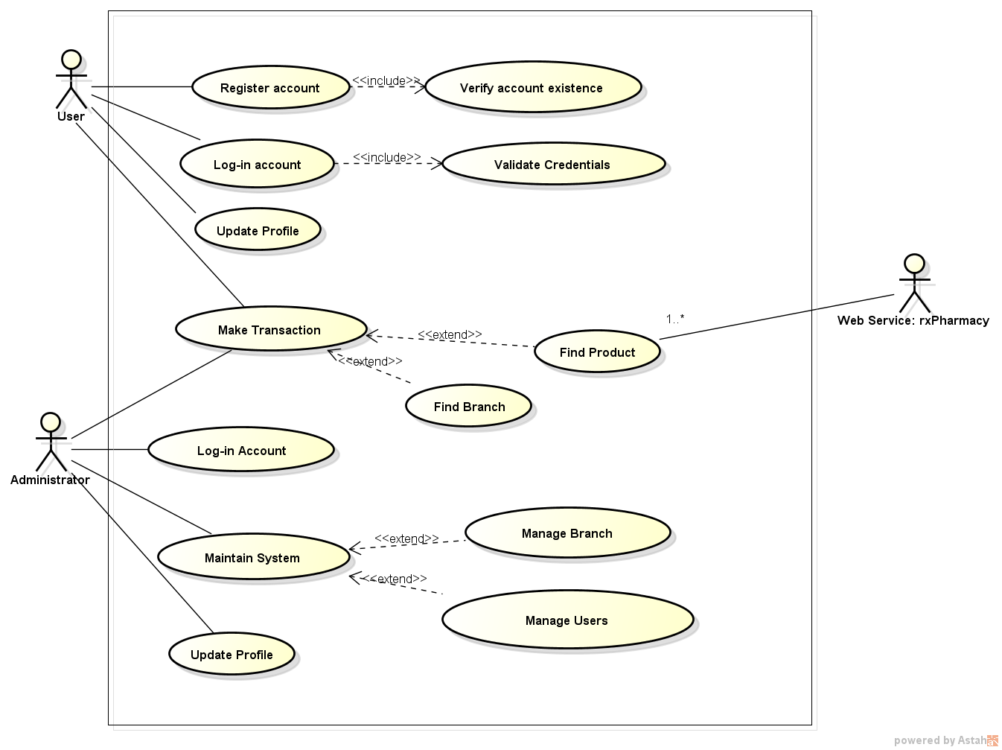

iii. User Interface

Login Page
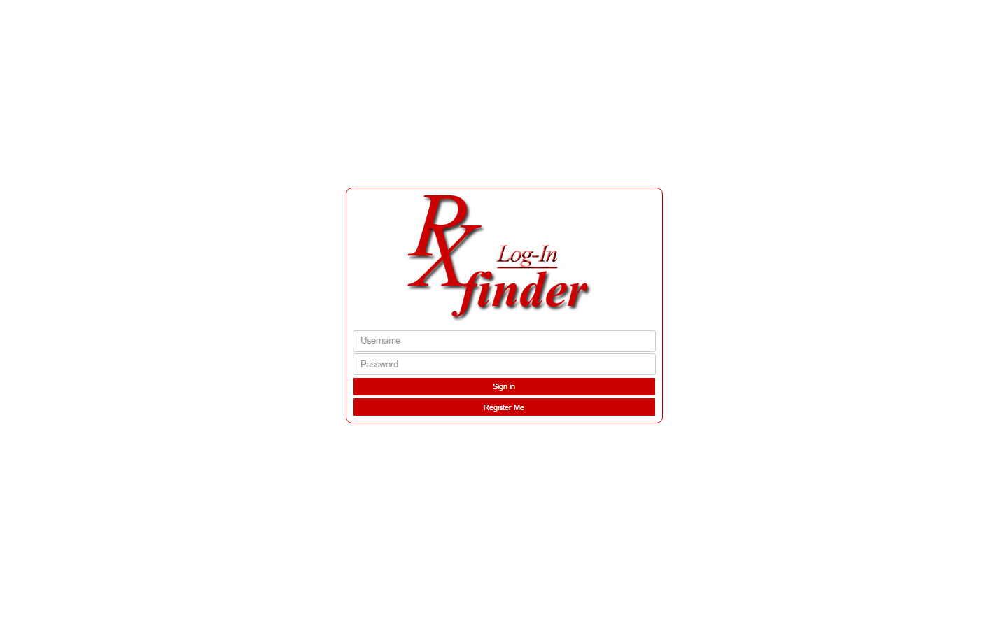

Registration Page
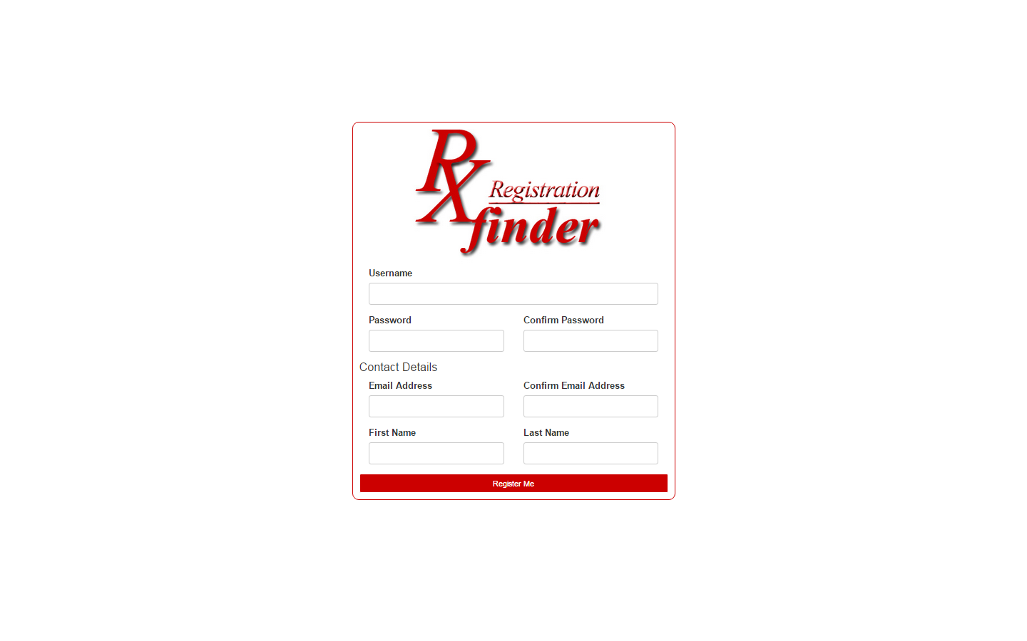

Update Profile Page

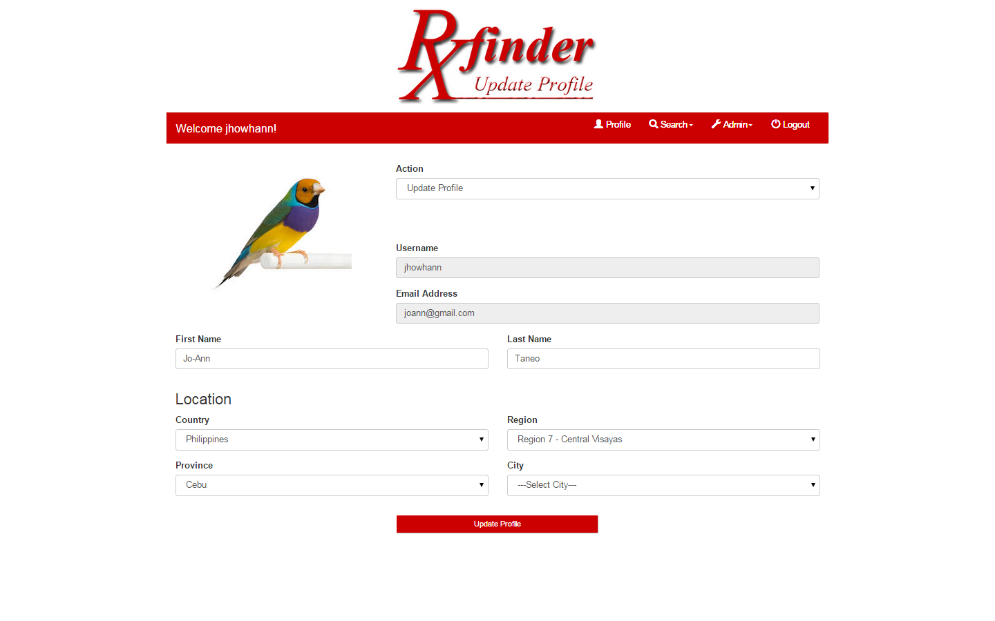

Find Branch Page
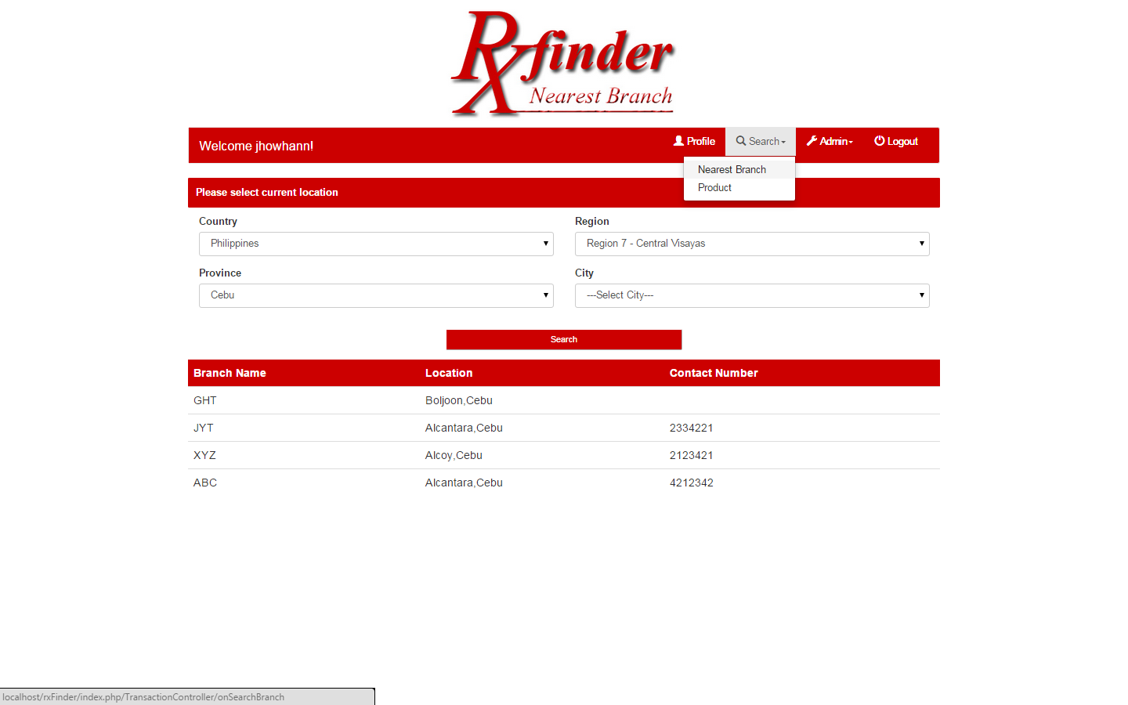

Find Product Page

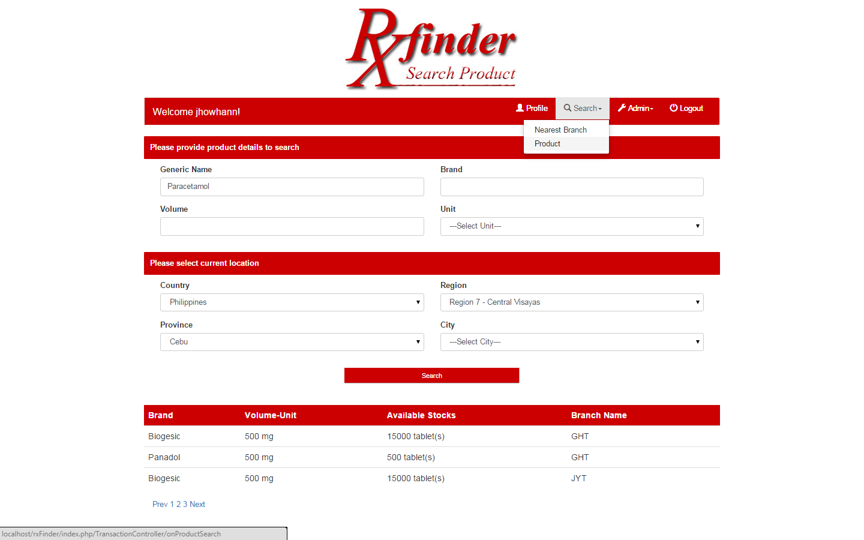

Branch Configuration Page
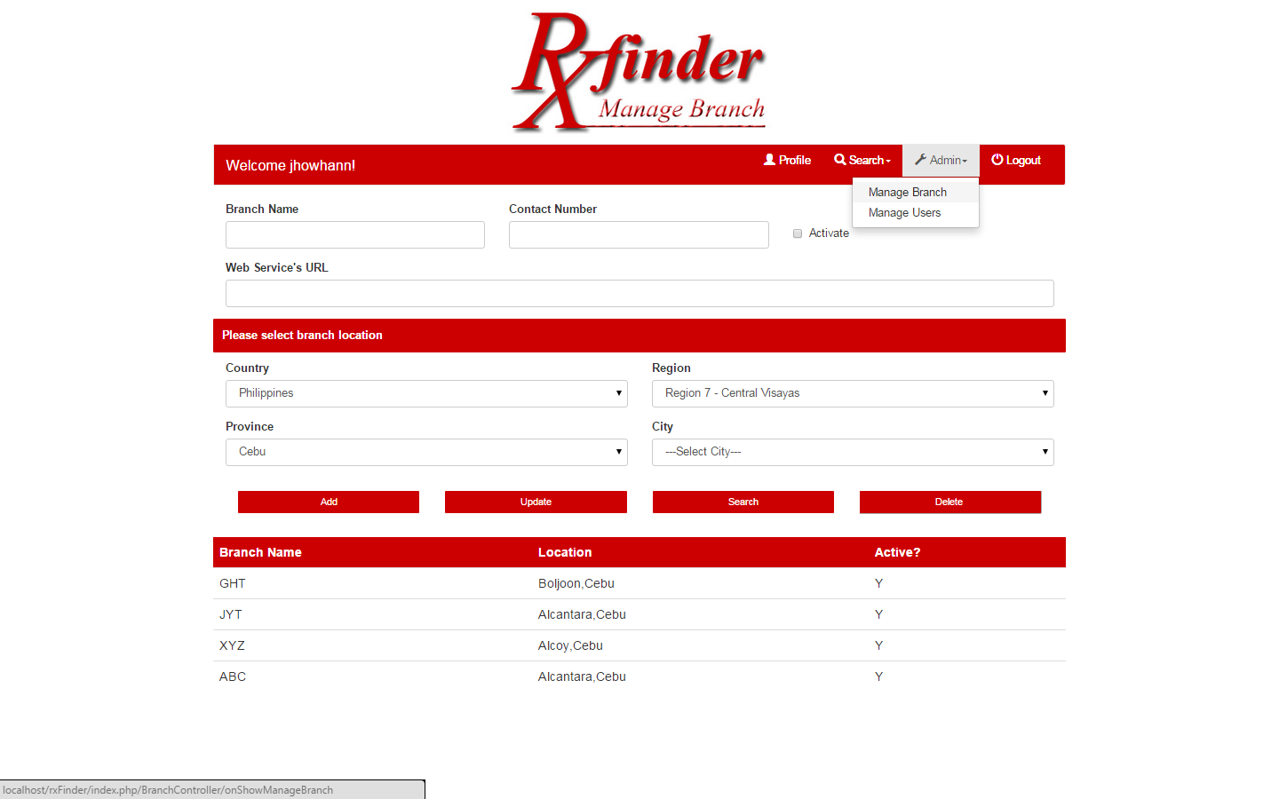

Manage User Page

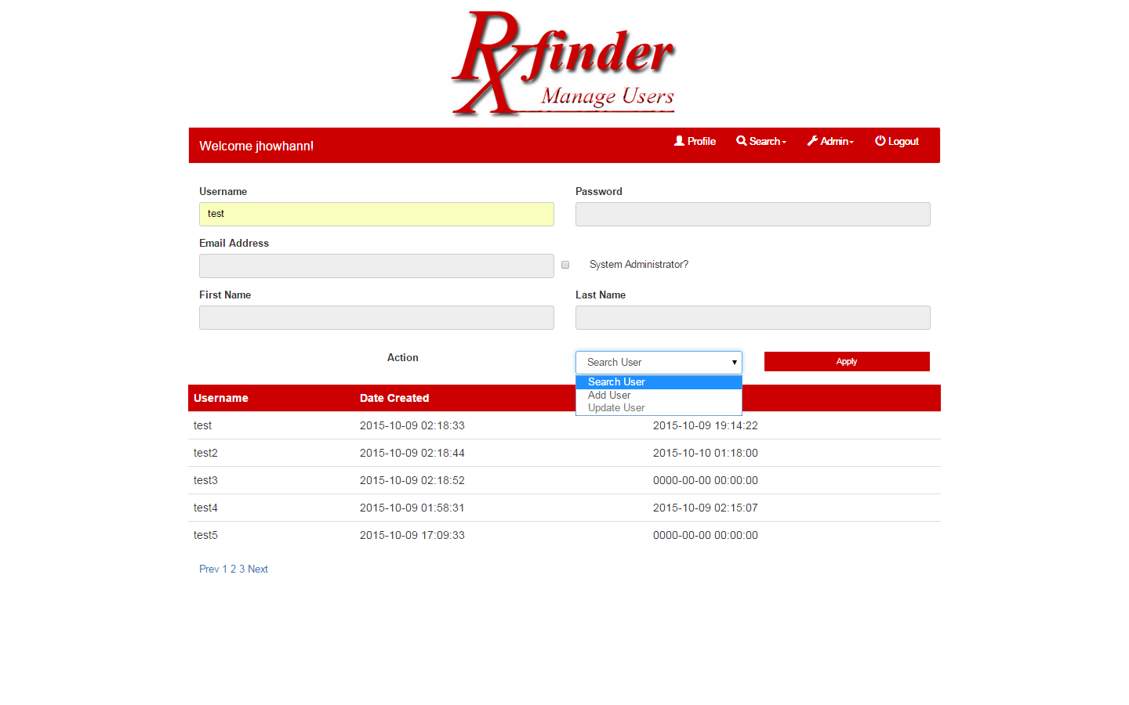

iv. Class Diagram

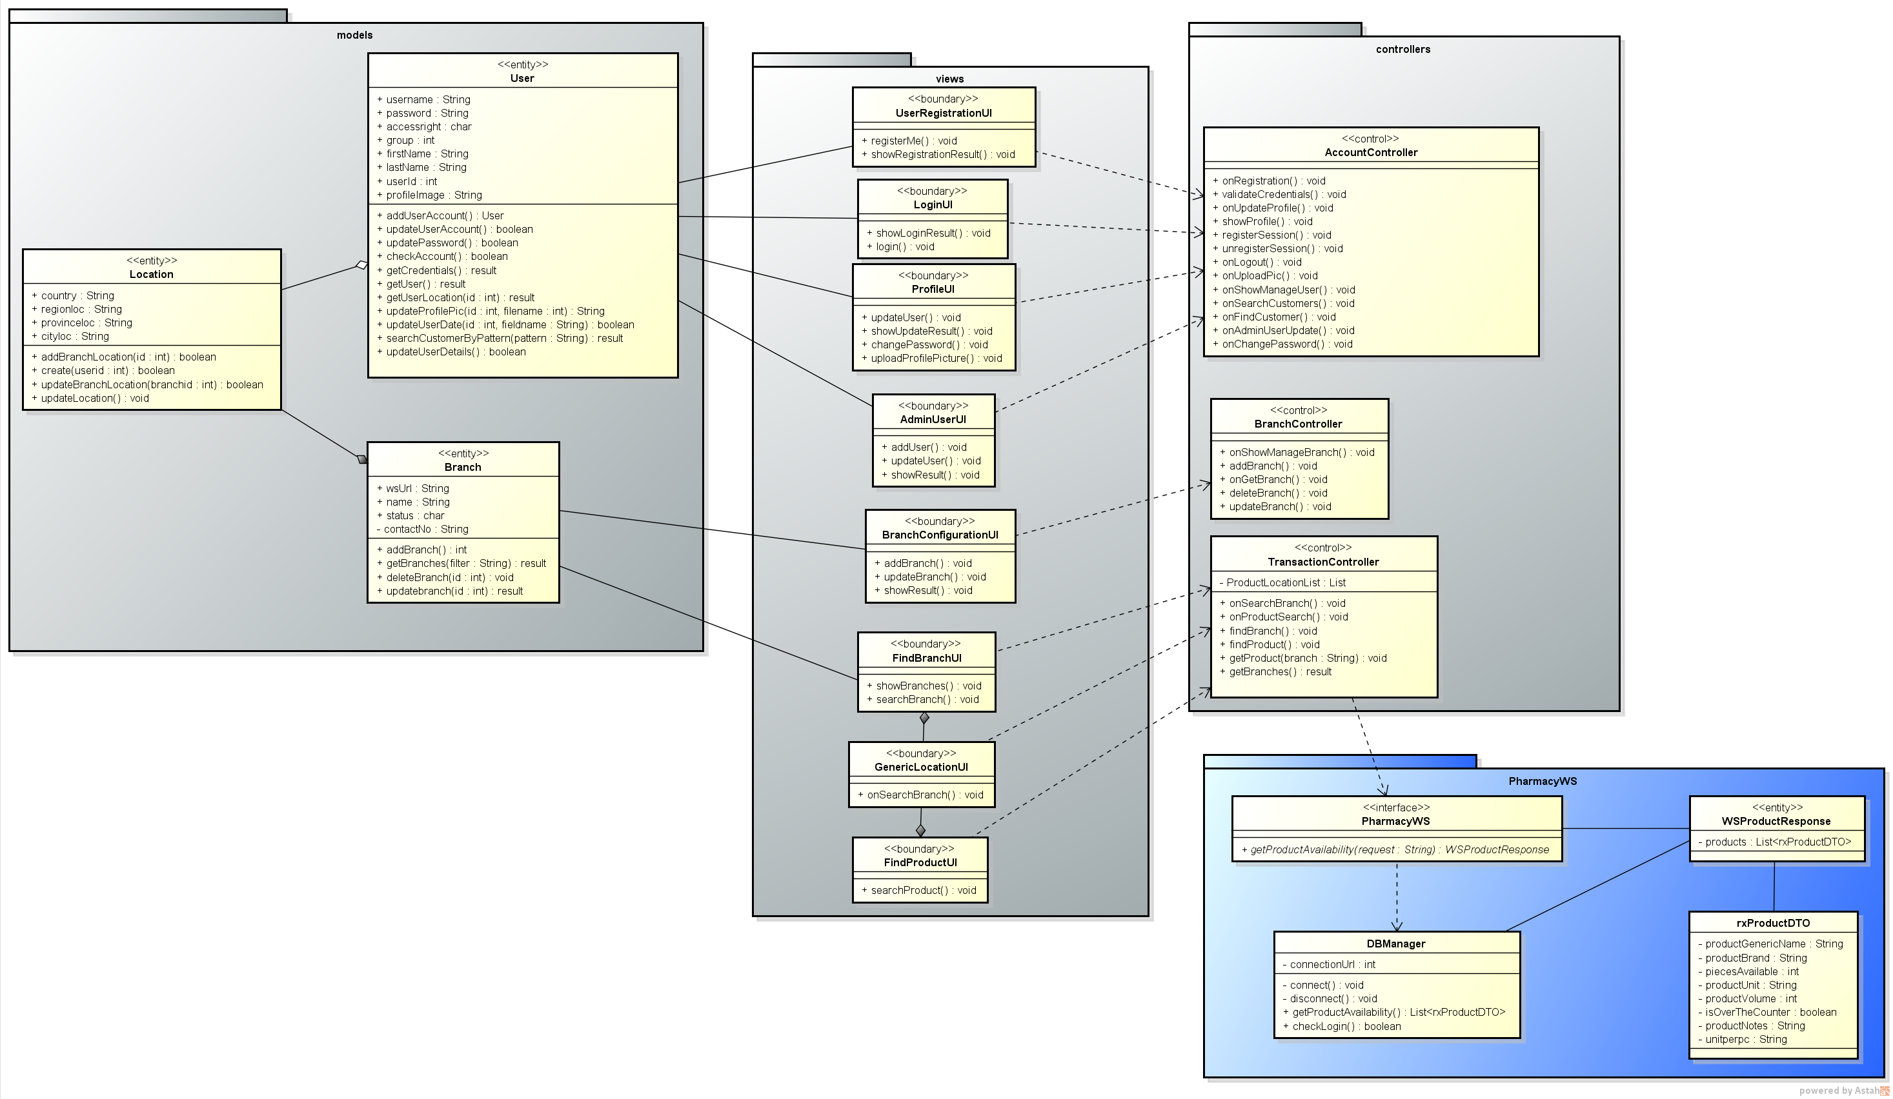

v. Sequence Diagram

User Log-in
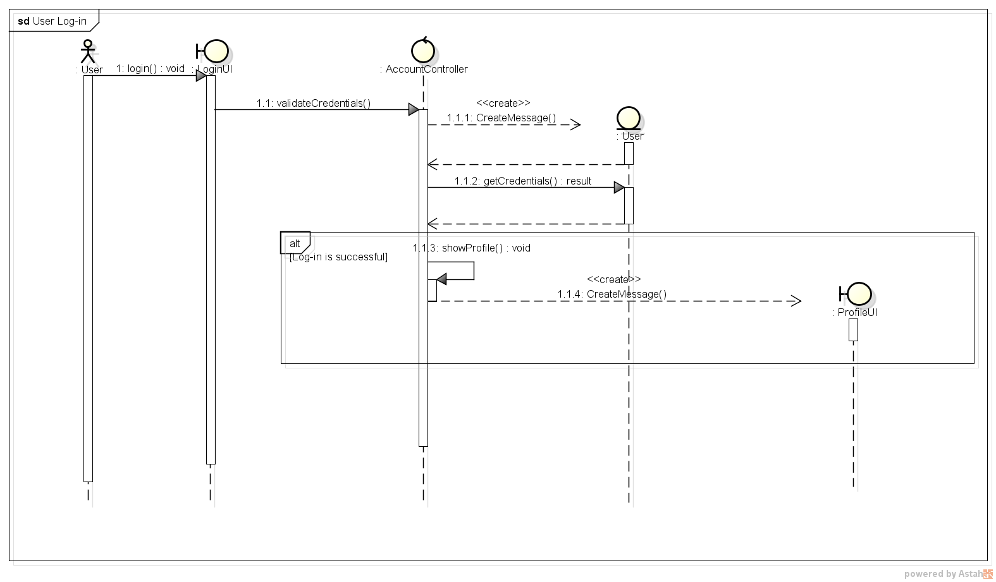
User Registration
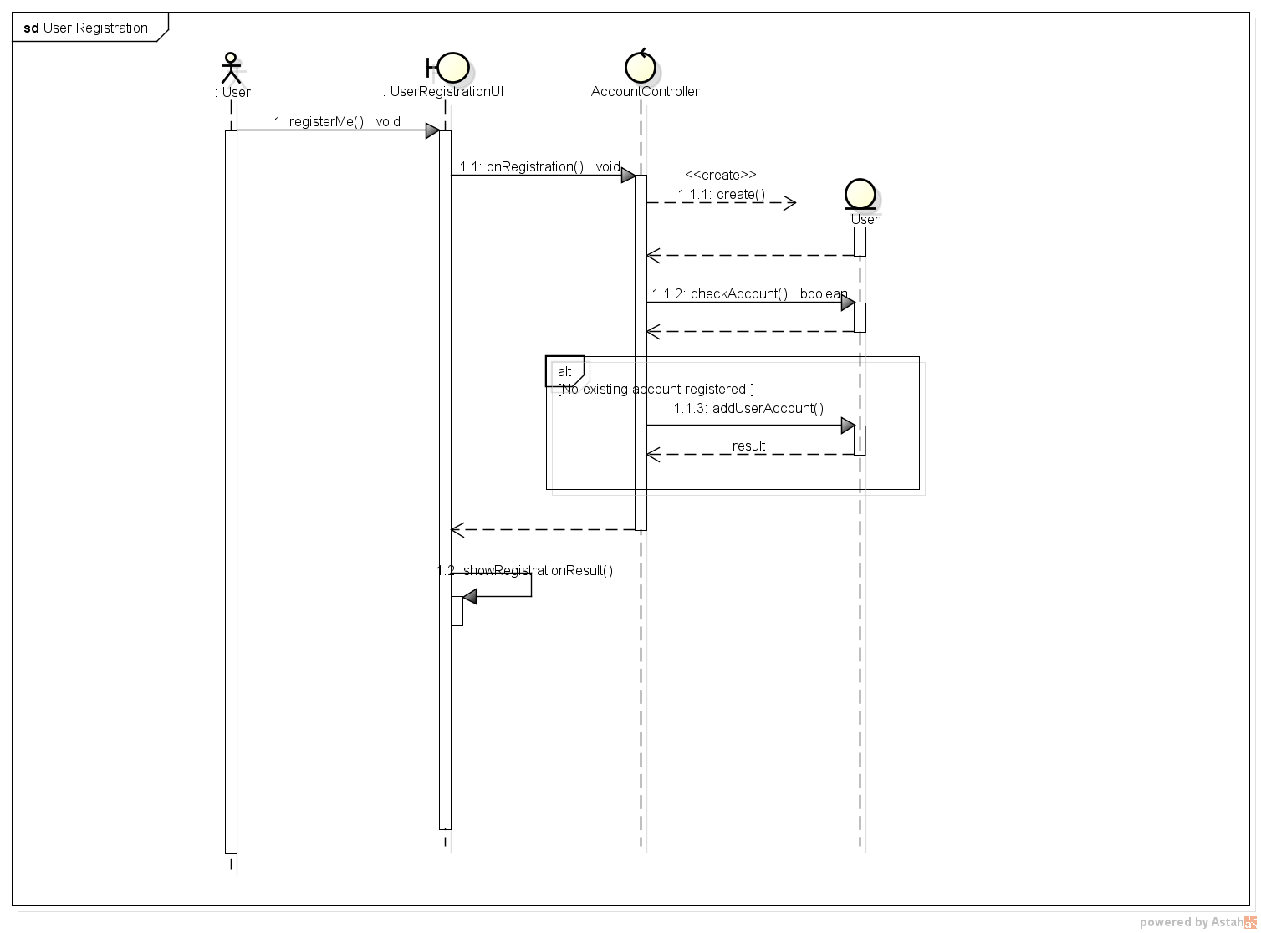
Update Profile
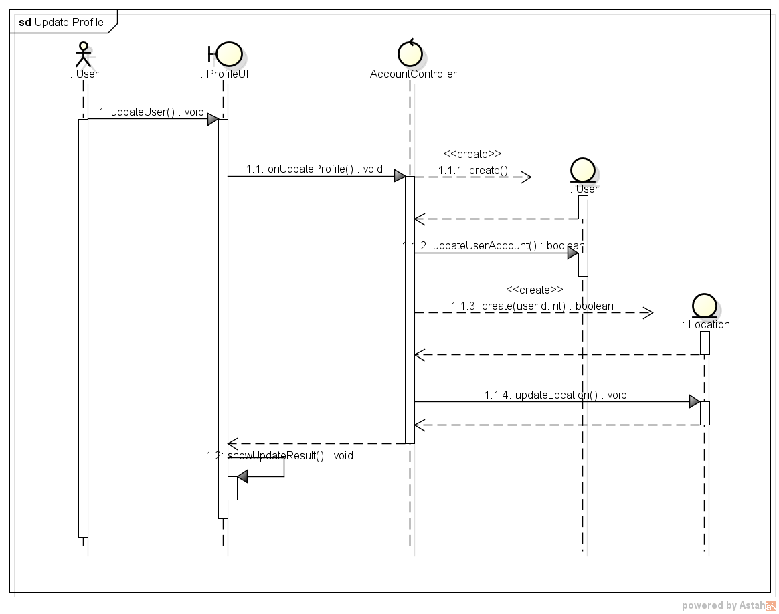
Locate Nearest Branch
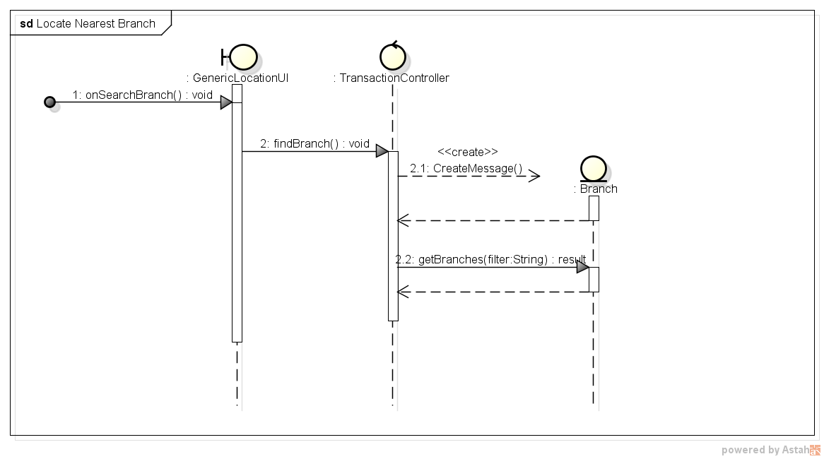

Find Branch

Find Product

Get Product Available – WS
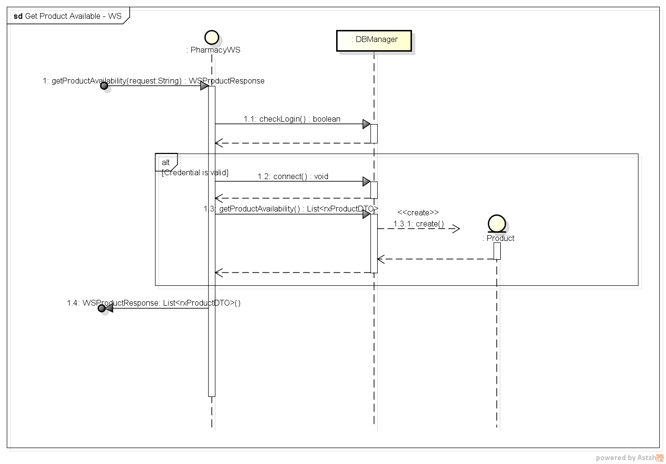

Manage Branch – Add
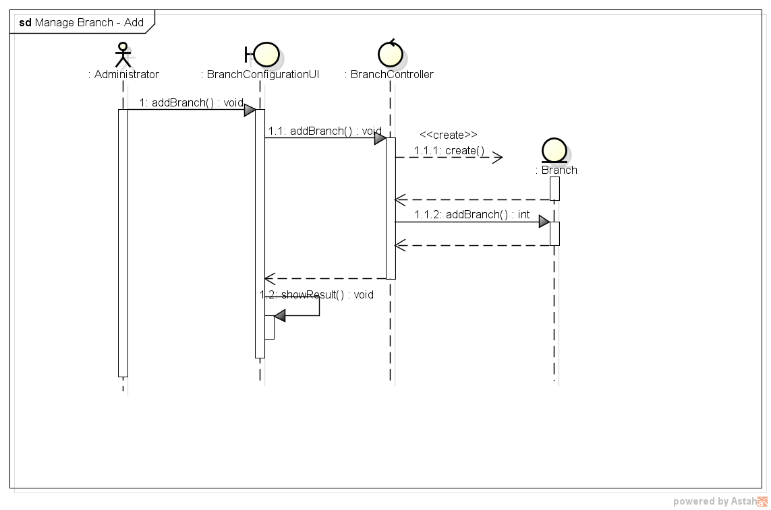
Manage Branch - Update
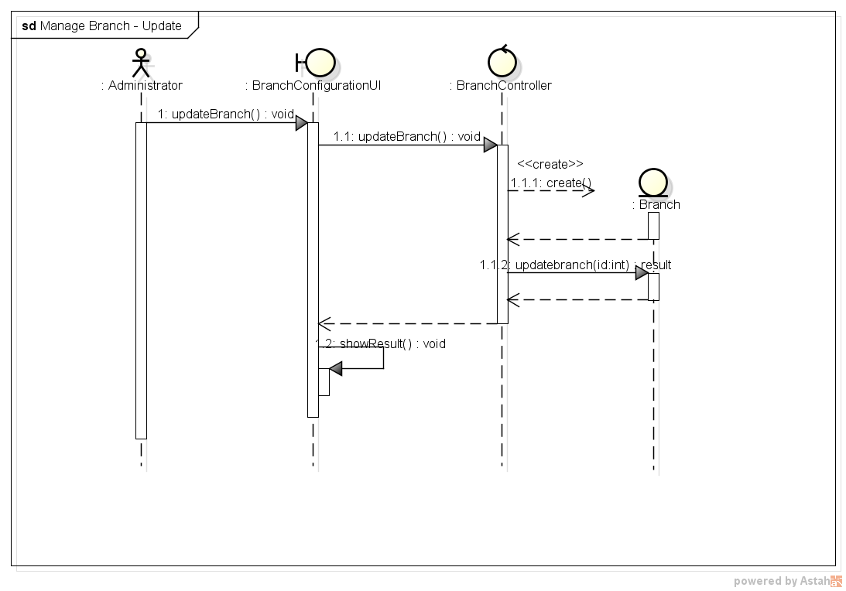
Manage User - Add
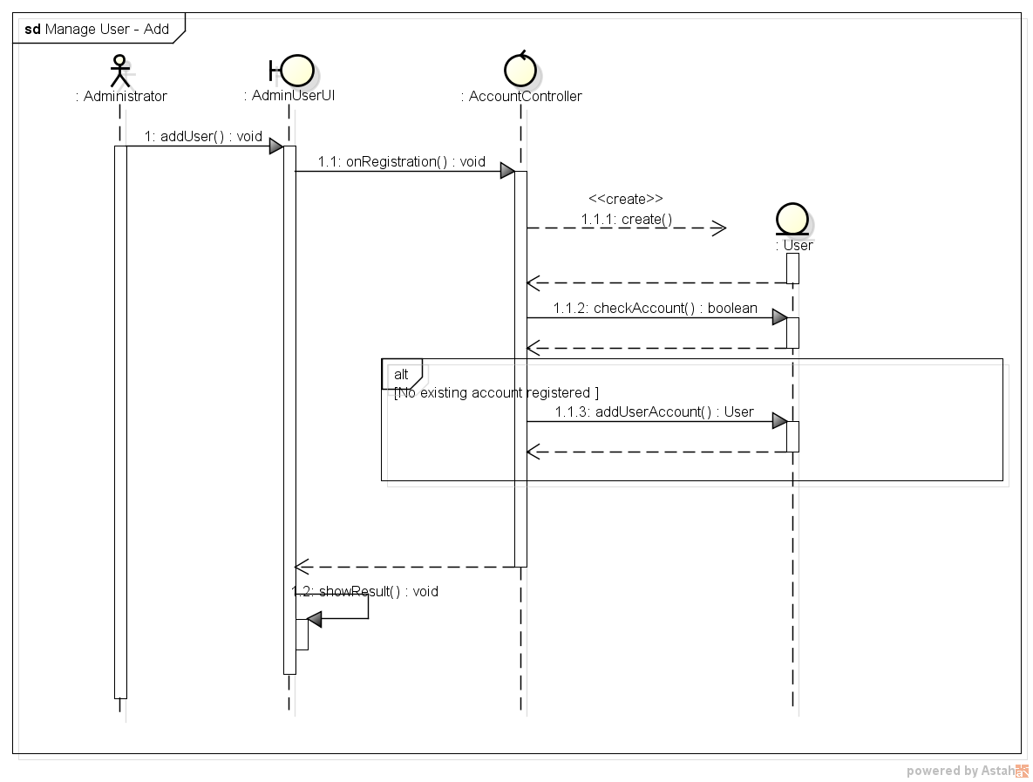
Manage User – Update
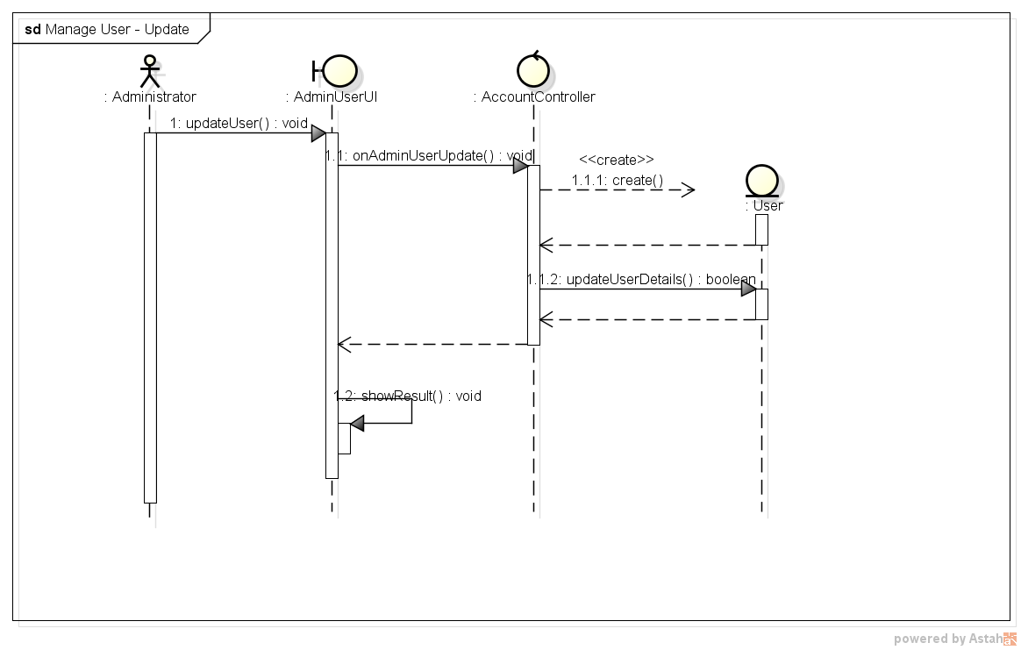

vi Entity Relationship Diagram

